CYBER SECURITY INTERNSHIP

TASK – 2

1. Installing a Linux Virtual Machine (VM) using VirtualBox
(OR using Windows Security Settings)
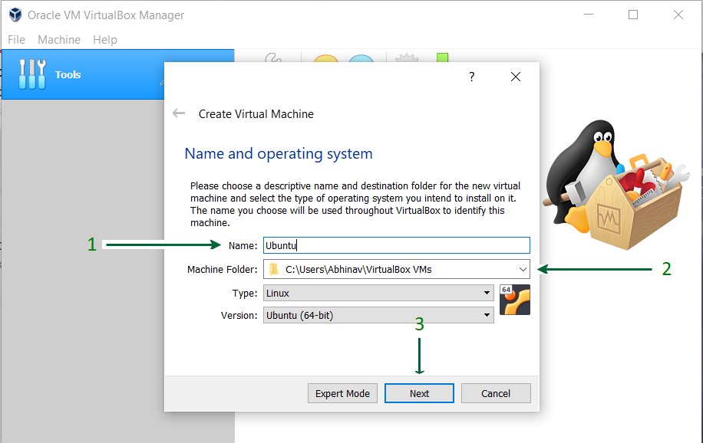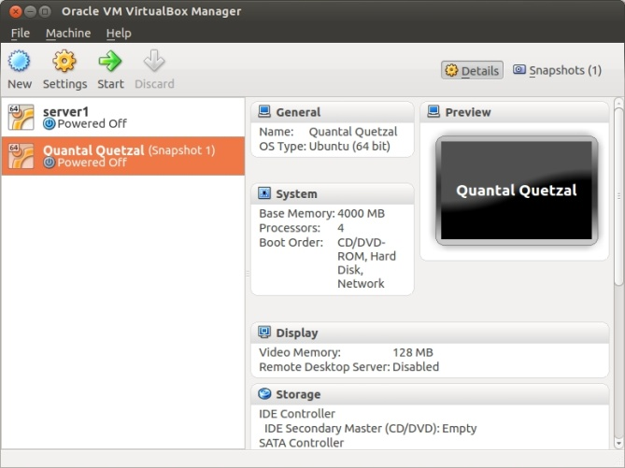

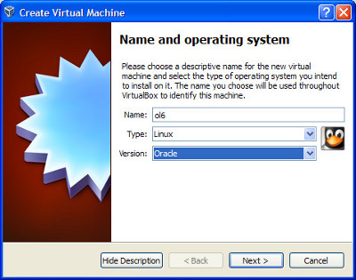

What is a Virtual Machine?
A Virtual Machine (VM) is a software-based computer that runs an operating system inside another OS using virtualization software like VirtualBox.

Why Use a VM in Cybersecurity?
- Safe testing environment
- Malware analysis without damaging host OS
- Practice Linux commands
- Learn system hardening safely

Steps to Install Linux VM using VirtualBox
- Download VirtualBox
- Download a Linux ISO (Ubuntu recommended)
- Open VirtualBox → New
- Set:
  - Name: Ubuntu
  - Type: Linux
  - Version: Ubuntu (64-bit)
- Allocate resources:
  - RAM: 2–4 GB
  - CPU: 2 cores
- Create Virtual Hard Disk (VDI, Dynamically Allocated)
- Attach ISO file
- Start VM → Install Ubuntu
- Create username and password

Alternative: Windows Security Settings
If VM is not available:
- Use Windows Defender
- Configure Firewall
- Enable User Account Control (UAC)
- Review Local Security Policies

Commands :
• pwd
• ls
• cd
• mkdir
• rmdir
• rm
• cp
• mv
• touch
• cat
• nano
• chmod
• chown
• ps
• top
• df
• du
• uname
• ip a
• sudo
• whoami
• who
• id
• history
• clear
• man
• grep
• find
• tar
• wget

2. User Accounts, Permissions & Access Control
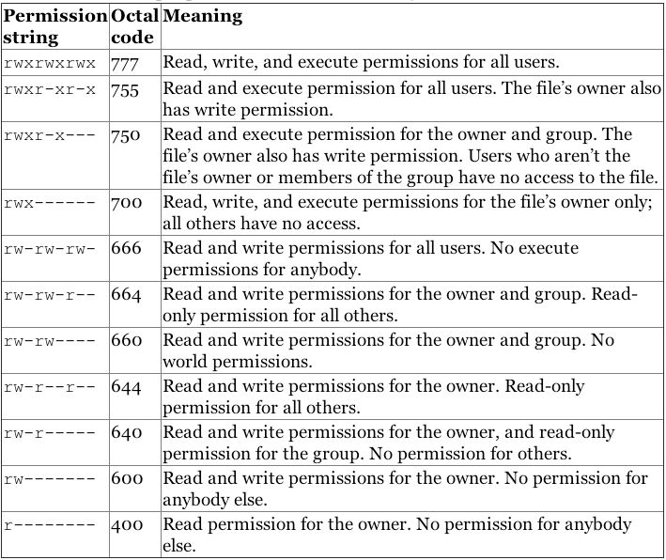

User Accounts in Linux
- Root User
  - Superuser
  - Full system access
- Standard User
  - Limited permissions
  - Requires sudo for admin tasks
- Service Accounts
  - Used by services (e.g., www-data)

Important Files
- /etc/passwd → user info
- /etc/shadow → encrypted passwords
- /etc/group → group information

Access Control Mechanisms
- DAC (Discretionary Access Control) → Owner controls permissions
- MAC (Mandatory Access Control) → SELinux / AppArmor
- RBAC (Role-Based Access Control) → Permissions based on roles

3. File Permissions: chmod, chown, ls -l
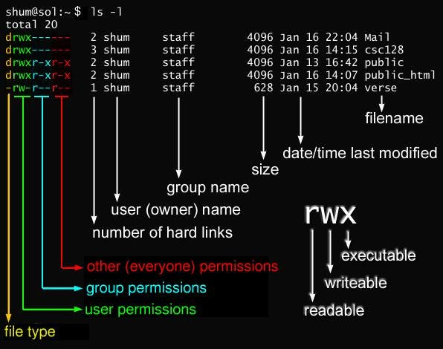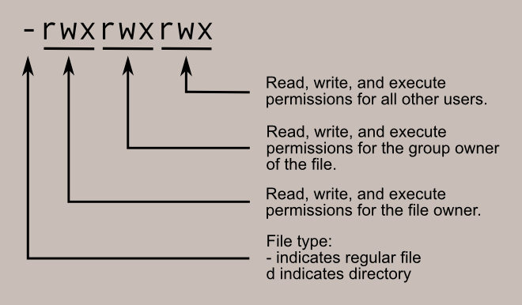

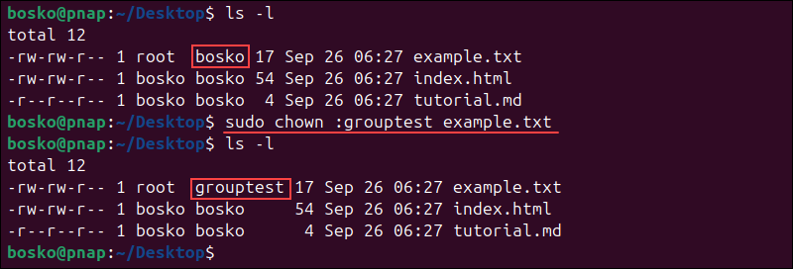

Understanding

ls -l
Example:
-rwxr-xr--

Breakdown
Part | Meaning
- | File type
rwx | Owner permissions
r-x | Group permissions
r-- | Others

Permission Values
Permission | Value
Read (r) | 4
Write (w) | 2
Execute (x) | 1

chmod Command
chmod 755 file.sh
- Owner: rwx (7)
- Group: r-x (5)
- Others: r-x (5)

chown Command
chown user:group file.txt
Changes file ownership.

4. Administrator vs Standard User Privileges

Administrator (Root / sudo)
- Install software
- Modify system files
- Start/stop services
- Manage users

Standard User
- Limited file access
- Cannot modify system files
- Uses sudo for admin actions

Security Best Practice
✔ Always use standard user
❌ Avoid logging in as root

5. Enabling Firewall (Linux UFW / Windows Firewall)

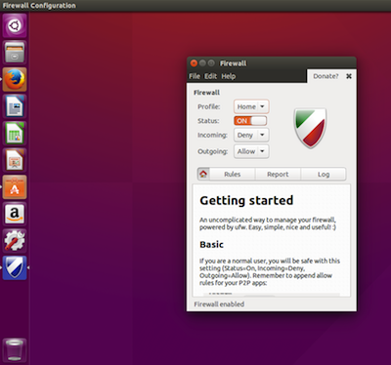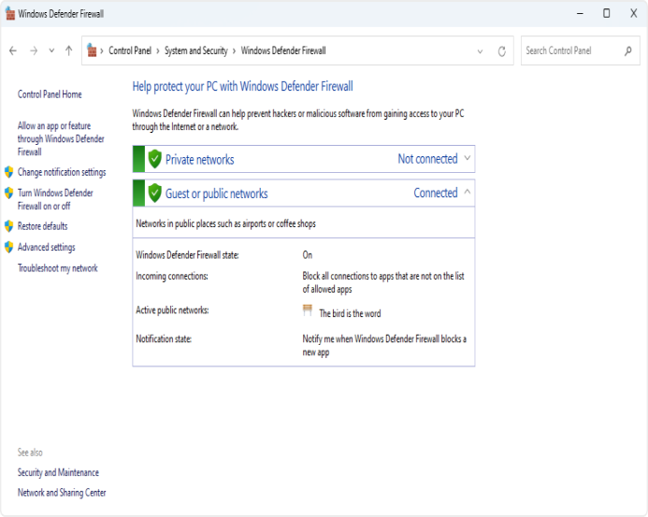

Linux – UFW (Uncomplicated Firewall)
sudo ufw enable
sudo ufw status

Allow SSH
sudo ufw allow ssh

Block a Port
sudo ufw deny 23

Windows Firewall
- Control inbound/outbound traffic
- Prevent unauthorized access
- Protect against malware communication

6. Identifying Running Processes & Services

Linux Commands
ps aux
top
htop

Check Services
systemctl list-units --type=service

Windows
- Task Manager
- Services.msc
- PowerShell:
Get-Service

Why This Matters?
- Detect suspicious processes
- Identify malware
- Monitor resource usage

7. Disable Unnecessary Services (Reduce Attack Surface)
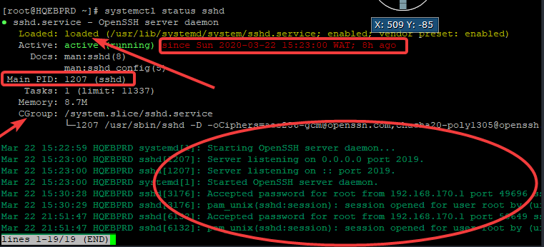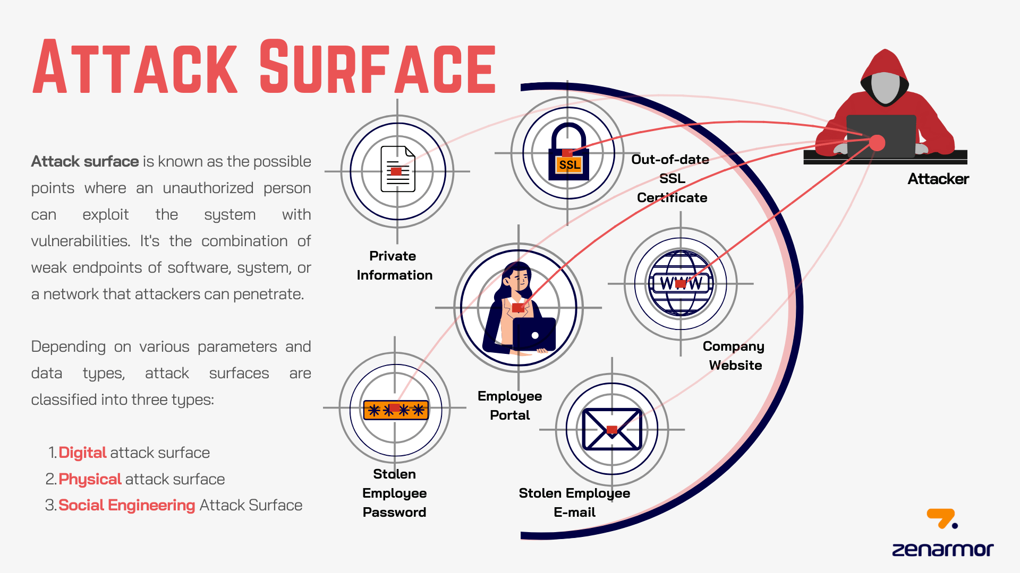

What is Attack Surface?
All points where an attacker can exploit a system.

Disable Services in Linux
sudo systemctl stop apache2
sudo systemctl disable apache2

Common Services to Review
- FTP
- Telnet
- Bluetooth
- Printing services (if unused)
✔ Less services = less vulnerabilities

8. OS Hardening Best Practices (Documentation)

OS Hardening Definition
Reducing vulnerabilities by configuring the OS securely.

Best Practices Checklist
✔ Use strong passwords
✔ Enable firewall
✔ Disable unused services
✔ Apply updates regularly
✔ Least privilege principle
✔ Monitor logs
✔ Use antivirus/EDR
✔ Encrypt disks
✔ Enable automatic security updates

Logs to Monitor (Linux)
- /var/log/auth.log
- /var/log/syslog

Logs to Monitor (Windows)
- Security Event Logs
- Application Logs

